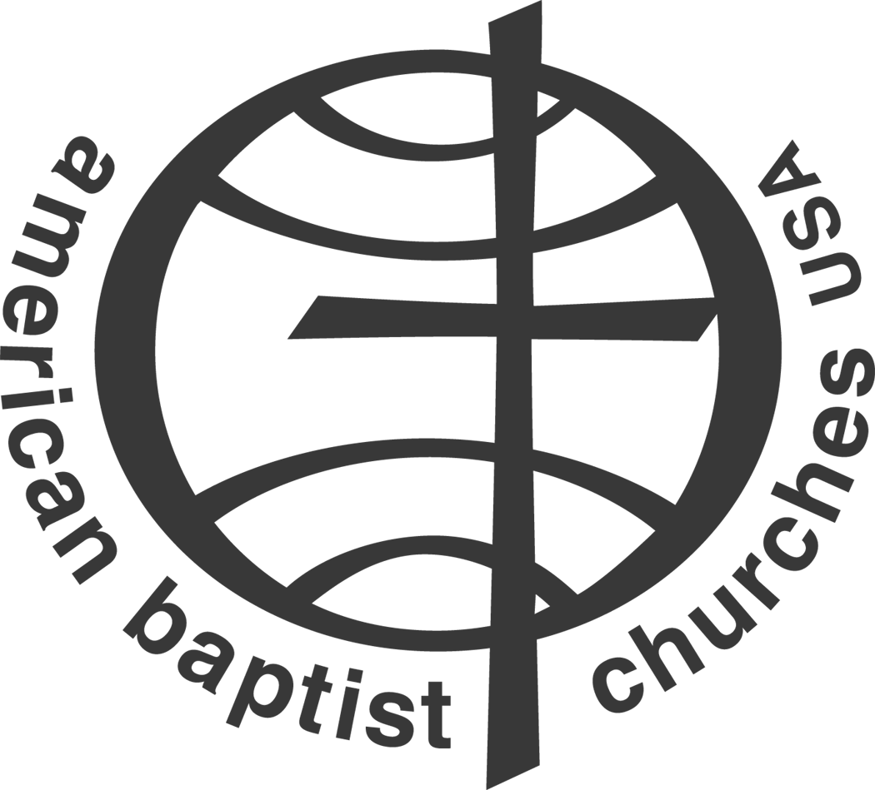

Process for Recognizing New Congregations
Wishing to Covenant with ABCRM

- Congregational leaders meet with Regional Staff and Representatives of Region Board. Several issues will be addressed in this meeting:
- Why do you want to be an American Baptist Church?
- What is your understanding of the American Baptist Churches in the USA?
- Summarize your church’s doctrine.
- Other questions as deemed appropriate by the committee.

- The petitioning church will be asked to align itself with the ABC/USA Common Criteria as a minimal qualification for a cooperating church defined in ABC/USA By-laws:
5.1.1 Common criteria. The following "common criteria" shall serve as the
minimal qualifications for a Cooperating Church:

- Affirm the statement entitled, “We are American Baptists” (revised 6/19/98) as descriptive of American Baptist faith and practice. (See full statement, Addendum #5)
- Affirm the mission/purpose of the American Baptist Churches USA and of the Region in which the church is a member.
- Participate in the life and mission of the American Baptist Churches at local, regional, national and international levels.
- Financially support the mission of the American Baptist Churches USA at a responsible level.
- Share with the family the impact of the church’s ministries in reaching the community and world for Christ by reporting annually on forms supplied by the region and/or the ABC/USA.
Additionally the petitioning church shall be asked to fulfill the criteria of a covenanting congregation defined in ABCRM By-laws:
      - Affirm and participate in the mission and purpose of the Region.
      - Conduct regular weekly services of worship and operate in conformity with generally accepted Baptist beliefs and practices.
      - Support the mission of the Region at responsible financial and volunteer levels. All churches are encouraged to give at least ten percent (10%) of their income to American Baptist mission, as a basis upon which to build their mission giving. Churches below this level are encouraged to move toward this goal at the rate of one percent (1%) per year. Congregations aligned with more than one denomination shall share their mission funds proportionally with these denominations.
      - Retain an American Baptist Pastor in good standing. A pastor who is not credentialed at the time of call by the congregation shall obtain recognition and good standing with the Region. A pastor of a multi-aligned congregation credentialed in another denomination shall obtain regional recognition for his or her credentials and maintain good standing with the Region.
      - Share with the ABC family the impact of the church’s ministries in reaching the community and world for Christ.

- The Region Staff and Board will carry the request of the petitioning church to nearby ABC Congregations to find two or more “Sponsoring Churches” for the Petitioning Congregation. These Congregations will agree to:
  - Work with the petitioning congregation to engage in cooperative mission and ministry in their communities.
  - Encourage the petitioning congregation in its support of Regional, National and International missions.
  - Encourage the professional leadership of their respective congregations to meet regularly for mutual support and encouragement.
  - Prepare a resolution and officially act as a congregation to affirm this resolution of sponsorship.

- When two or more sponsoring congregations have been identified and their resolutions of sponsorship received, the petition for membership to the Region will be forwarded to the Board for consideration.

- The Executive Minister will notify the ABC/USA of the affirmative action taken by the Region. The General Board of the ABC/USA will vote at their next meeting to receive the church as a member church of the ABC/USA.

Adopted by Executive Committee Vote
May 31, 2008

